Introduction
In this lab we will explore modeling network paths using a location-allocation problem and a vehicle routing problem. We will be creating a network dataset, which will allow us to allocate resources and create least-cost paths along a network.

Part I: Relocating the Fire Stations
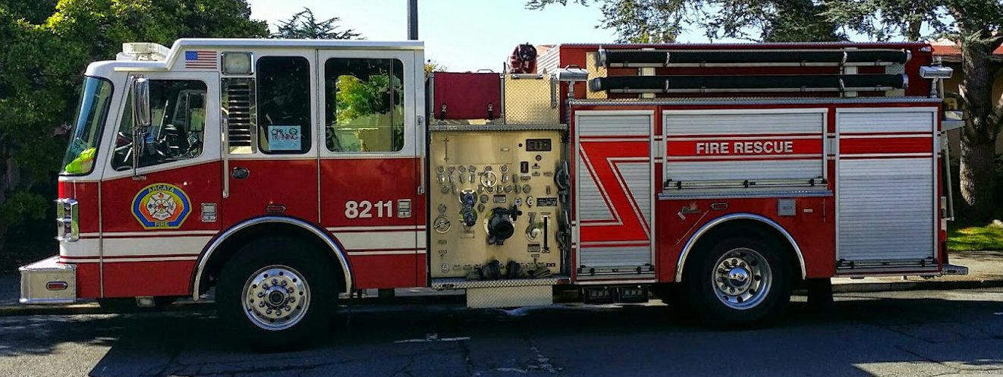
Photo by Nicolas R. Malloy
In our first scenario, the Arcata Fire Protection District has decided to explore the possibility of updating their facilities and relocating the existing fire departments serving the cities of Arcata and McKinleyville. A number of potential sites have been identified, but it is not certain which location will optimize services between these two cities. We will attempt to answer this question using a location-allocation solver available through the ArcGIS Network Analyst extension.
We will use the following criteria in our analysis:
- A history of incident responses over seven years
- The location of three potential sites from Arcata to McKinleyville
- A two minute response time window which captures the greatest demand based on incident history
- A five minute response time window which captures the greatest demand based on incident history
- A comparison between potential sites and existing fire stations.
- We will be conducting our analysis in NAD83 UTM Zone 10 N

Learning Outcomes
- Review adding XY data
- Review Data Management Tools: project, define projection
- Create a network dataset
- Identify problems that can be solved with Location-Allocation
- Adjust model parameters to find the best location
- Identify problems that can be solved with the Vehicle Routing Problem solver
- Adjust model parameters to create and manage delivery routes based on a set of route constraints
- Evaluate results of network analysis based on location and cost
- Review creating a 6 inch map layout for use as a figure in a report
- Present a report using MS Word

Skill Drill: Setting up Your Workspace
By now you should be familiar with file management protocols for GIS. In a workplace setting, having consistent file management protocols is necessary to prevent errors and lost data.
Set up your basic folder structure for this project within a parent folder (originals, working, final).
- Navigate to the lab05 data folder on Moodle.
- Download and unzip the data into your originals folder.
- Launch ArcMap and enable the Network Analyst extension.
- Open the Network Analyst tool bar and dock it near the top of your window for easy access.
- On the Network Analyst toolbar, click the Show/Hide Network Analyst Window button .
- Dock the Network Analyst Window on the right side of your screen.

Walk Through: Creating A Network Dataset
In order to conduct our network analysis, you must first create a network dataset with roads (edges) and intersections (junctions). A network dataset is created from source features, such as lines and points, and stores the connectivity between them. In this case, we will use a roads layer for Humboldt County to build our network dataset.
- Using the ArcCatalog Window, navigate to your originals folder and right click on humroads.shp and select “New Network Dataset”.
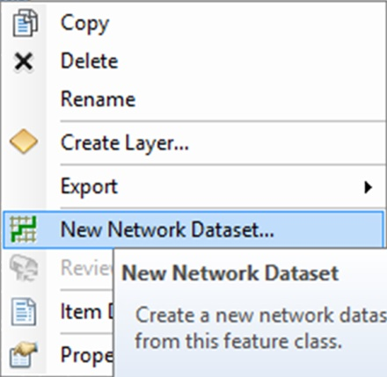
- Accept the default name and click next.
- Click next to accept the default “Yes” for modeling turns in the network.
- Click next to accept the default connectivity settings.
- This dataset does not contain a field with elevation information. Click next to accept the default “None” for elevation settings.
- We need to specify the attributes for the network dataset. Double click the “Length” attribute.
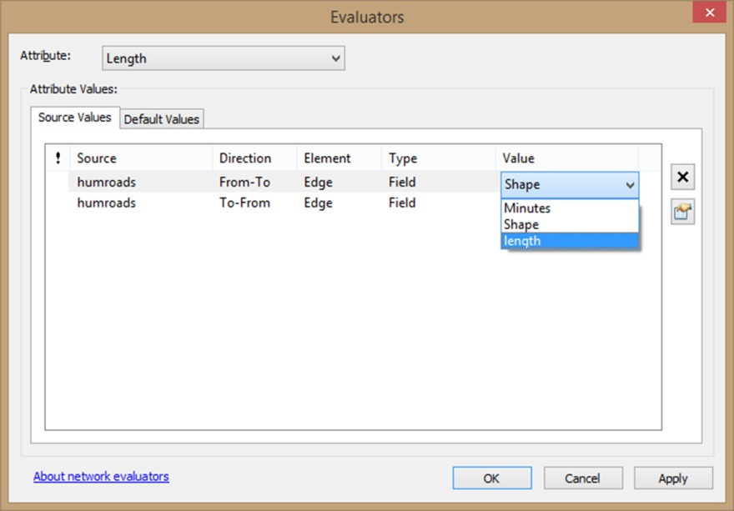
- Change the value field from “Shape” to “length” for both “From-To” and “To-From” directions.
- Click OK.
- Double click the “Minutes” attribute and verify that the value field is set to “Minutes”.
- Click OK.
- Click Next.
- Click Next to accept the default “Yes” for driving direction settings.
- Click Finish.
- Click “Yes” to build the network dataset now.
- Click “Yes” to add all feature classes that participate in the network dataset.
Adding all the feature classes that participate in the network dataset is not necessary to our analysis, but it will allow us to take a closer look at the source elements that comprise the network dataset. We will remove these layers shortly.
- Zoom in to the intersection of Highway 101 and Samoa Blvd.

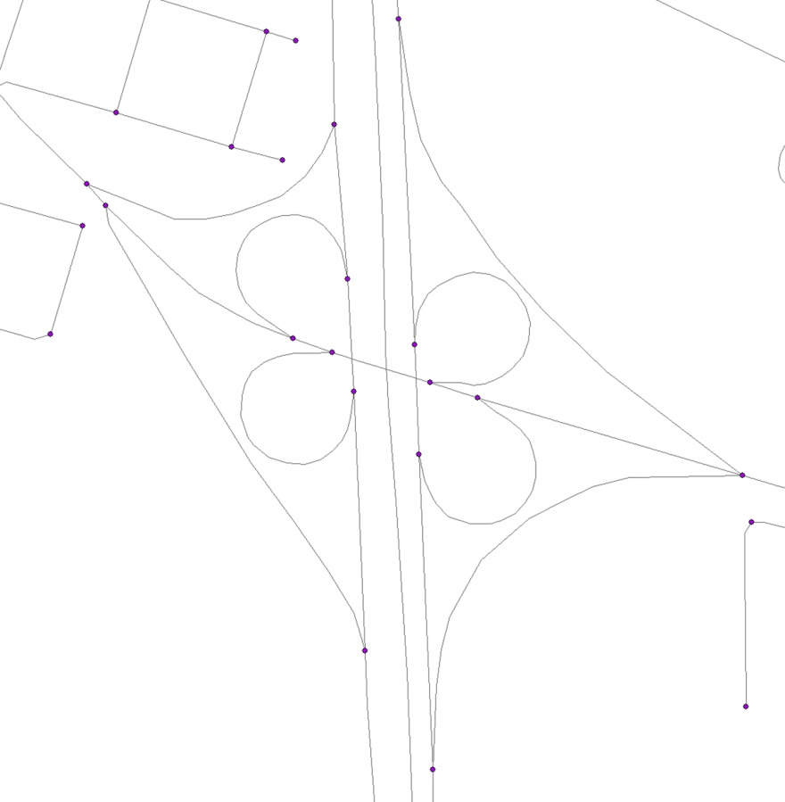
Take a moment to inspect the network dataset. It uses the “humroads” and “humroads_ND_Junctions” layers as its source elements and manages the connectivity between them. This allows the network dataset to model direction and turns along the network. As you can see, the junctions control where the edges connect and where turns are allowed in this clover leaf. Movement from one edge segment to another is only allowed at the junctions. Even though Samoa Blvd. crosses directly over the 101 centerline, there is no junction at this intersection. This means the network will not inadvertently model a turn at these coincident locations. The network path will be forced to move along the clover leaf on-ramps and off-ramps.
- Remove the “humroads” and the “humroads_ND_Junctions” layers from the table of contents, leaving only the “humroads_ND” network dataset.

Walk Through: Using Location-Allocation to Find Suitable Sites
- From the ArcCatalog Window, drag the “potential_sites.shp” onto your map.
- Right click on “potential_sites” in the Table of Contents and “Zoom to Layer”.
- From the ArcCatalog Window, drag the “incident_history.shp” onto your map.
- Take a moment to inspect the attribute table.
- Change the symbology to “Graduated Symbols” accepting the default classification scheme.
- Zoom in to the city of McKinleyville, then Arcata. Take a moment to observe the patterns of incident history.
These incident locations have been aggregated to 30 meters and specific details about the incidents have been removed to protect the privacy of individuals.
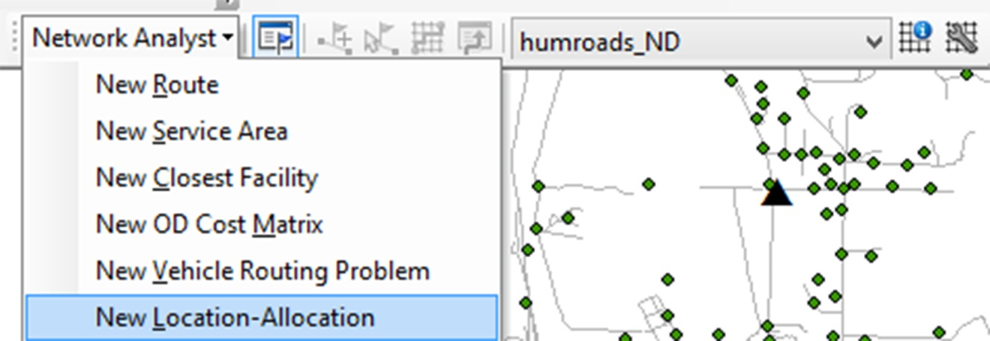
- From the Network Analyst toolbar add a “New Location-Allocation”.
A new group layer called “Location-Allocation” now appears in your Table of Contents as well as in the Network Analyst Window. It is currently made up of empty layers.
We will now load our potential fire station locations as ‘Facilities” in our analysis.
- Right click on “Facilities” in the Network Analyst Window and select “Load Locations…”.
- Choose the “potential_sites” layer from the “Load From:” drop down menu.
- You may leave all other settings as default and click OK.
We will now load our history of incidents as “Demand Points” in our analysis.
- Right click on Demand Points in the Network Analyst window and select “Load Locations…”.
- Choose the “incident_history” layer from the “Load From:” drop down menu.
- In the Field column next to Weight, set the field to ICOUNT.
This will weigh the features based on the number of incidents at that location.
- Click OK. This may take a few moments to load.
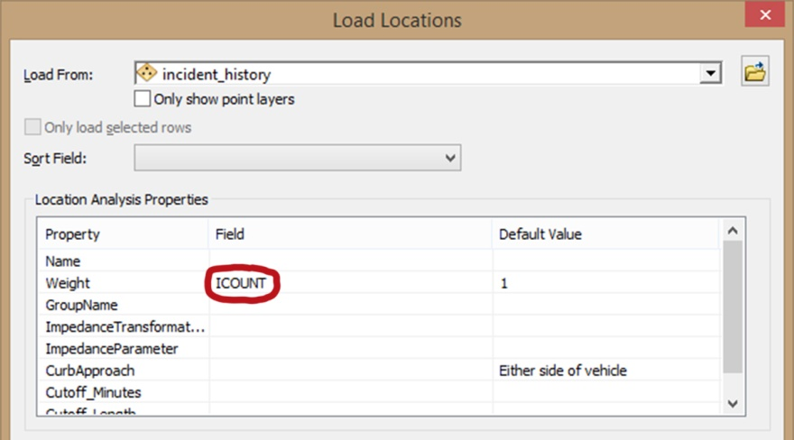
- Click on the Location Allocation Properties button in the Network Analyst Window .
- Click the Analysis Settings tab and inspect the current settings. The impedance should be set to “Minutes (Minutes)” and the “Travel From:” setting should be “Facility to Demand”.
- Click the Advanced Settings tab
Here we will specify our problem type, how many facilities to choose from, and the distance (in minutes) we will use to base our location-allocation.
- Next to “Problem Type:”, select “Maximize Attendance”.
- Next to “Facilities To Choose:”, enter 3.
- Next to “Impedance Cutoff:”, enter 2.
- “Impedance Transformation” should be set to “Linear”.
- Click OK.
We are now ready to run our model.
- In the Network Analyst Tool bar, click the Solve button to run the model.
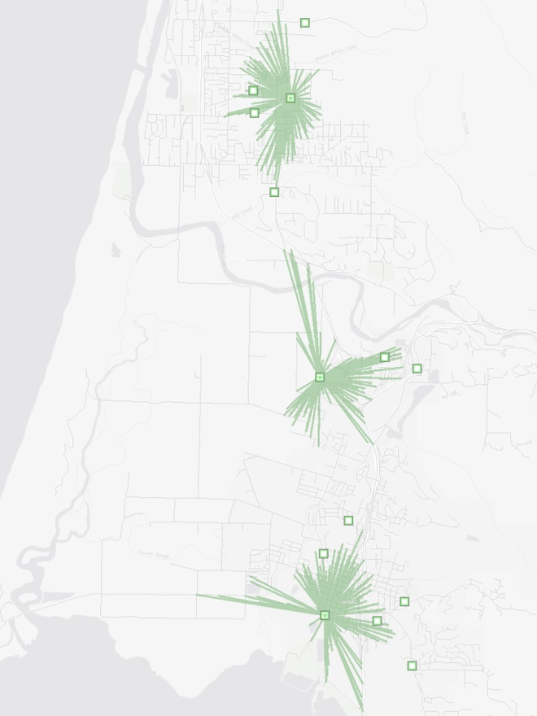
- Open the attribute table of the “Facilities” layer in the Table of Contents and view the results.
Each of the chosen facilities has been given a demand count and a demand weight indicating the total number of demand locations captured and the total apportioned sum of the weight field values. The demand weight values decay with distance.
- Create a map layout of your results. Be sure it is exported at the appropriate size for you report.

Skill Drill: Re-run the Model with Modified Parameters
The Arcata Fire department prefers a two-minute response time, but will consider facilities that can capture the most responses within a five-minute window.
- Create a table documenting the name of the three best facilities within a two minute response time. Be sure to include the “Demand Count” and “Demand Weight” for each chosen facility.
- Re-run the model using an impedance cutoff value of five minutes.
- Record the new results in your table and create a map layout.
There has also been a little push-back from the community about changing the location of the fire stations. The push-back has been particularly strong regarding the original Arcata Fire Station, which has a long history at that location. The fire chief is interested to know how the existing fire stations locations compare to the proposed sites.
- From the ArcCatalog Window, drag the “ExistingFireStations.shp” onto your map.
- Load the “ExistingFireStations” layer on to your “Facilities” in the Network Analyst Window, accepting all of the defaults.
- Keep the five minute impedance cutoff value and re-run the model.
- Record the new results in your table and create a map layout.
- Save your mxd.

Part II: Optimizing Organic Waste Diversion

Photo by Stephen Woods
In this scenario, the Humboldt Waste Management Authority has begun an Organic Waste Diversion pilot program for the collection of compostable organic waste. This waste stream represents a significant portion of waste generated in Humboldt County. The diversion of organic waste has the potential to reduce hauling costs, offset greenhouse gas emissions, and generate energy. Organic waste diversion represents the newest frontier in the waste management industry.
We will use the following criteria in our analysis:
- A list of commercial businesses who have volunteered for the pilot program.
- A single route/truck based on operating costs (distance and time).
- Multiple routes/trucks based operating costs (distance and time).

Skill Drill: Setting up and Adding XY Data
Open a new blank mxd in ArcMap and add the following: humroads_ND.nd and GarbageStation.shp. Our list of participants can be found in a text file called “participants.txt” containing georeferenced commercial locations. The locations were georeferenced using GCS WGS 1984. Add this text file to the map and convert it into a shapefile. Be sure the new shapefile is projected into NAD83 UTM Zone 10 N. Zoom in to the “participants” layer.

Walk Though: Modeling a Vehicle Routing Problem (VRP)
There are a great number of variables that can be used while modeling a Vehicle Routing Problem (VRP) relating to routes, drivers, vehicles, pickup locations, drop-off locations, and costs. This can help you to optimize routes for a wide variety of logistical operations. In this scenario will use the operating expense of the trucks broken down by cost per mile. We will also factor in the cost of labor in terms of cost per minute. In our first model, we will explore the results of using a route comprised of one truck and one driver.
- In the Network Analyst Tool bar, choose New Vehicle Routing Problem
We will now load our participant locations as ‘Orders” in our analysis.
- Right click on “Orders” in the “Network Analyst” window and “Load Locations…”
- Choose the “participants” layer from the “Load From:” drop down menu.
- In the field column next to “Description” choose “Address”.
- In the field column next to “ServiceTime” choose “Serv_Time”.
- In the field column next to “TimeWindowStart1” choose “Time_Start”.
- In the field column next to “TimeWindowEnd1” choose “Time_End”.
- In the field column next to “PickUpQuantities” choose “lbs”.
- In the Default Value column next to “CurbApproach” choose “Right Side of Vehicle”.
- Click OK.
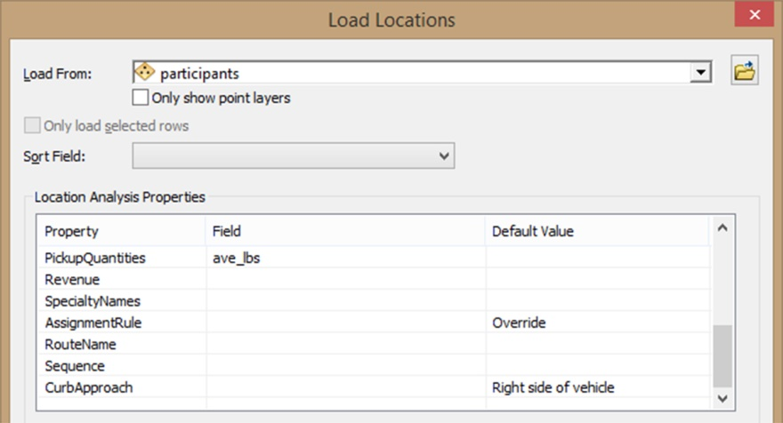
We will now load our garbage station as a ‘Depot” in our analysis. Depots are where the garbage trucks will start and finish their routes. It will include information such when the depot opens and closes.
- Right click on “Depots” in the Network Analyst window and “Load Locations…”.
- Select “GarbageStation” for the “Load From:” .
- In the field column next to “Name” choose “Name”.
- Under Default Value for “TimeWindowStart1” type in “5AM” and hit enter.
- Under Default Value for “TimeWindowEnd1” type in “7PM” and hit enter.
- Click OK.
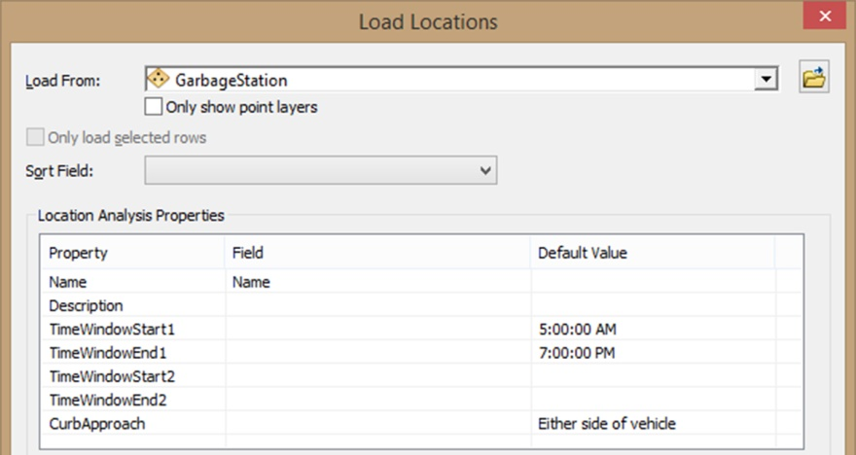
We will now enter information about our first route. This can include information about the trucks, drivers, and cost. In our first model, we will only enter one route manually in the “Properties – Routes” window.
- Right click on “Routes” in the Network Analyst window and “Add Item”.
- In the “Properties – Routes” window, next to “Name” enter “Truck1”.
- Next to “Description” enter “side-load”.
- Next to “StartDepotName” select “Eureka Station” from the drop-down menu.
- Next to “EndDepotName” select “Eureka Station” from the drop-down menu.
- Next to “StartDepotServiceTime” enter “15”. It takes 15 minutes to prep a side-load truck at the start of the shift.
- Next to “EndDepotServiceTime” enter “30”. It takes 30 minutes to empty and clean a side-load truck at the end of the shift.
- Next to “EarliestStartTime” type “5AM” and hit enter.
- Next to “LatestStartTime” type “6AM” and hit enter.
- Next to “Capacities” enter “20000”. A side-load truck can carry 20,000 lbs. before it needs to be emptied.
- Next to “CostPerUnitTime” enter “0.75”. This represents the driver’s cost of labor.
- Next to “CostPerUnitDistance” enter “3.95”. A side-loader has an average maintenance and gasoline cost of $3.95 a mile.
- Next to “OvertimeStartTime” enter “540”. Overtime pay for the driver begins after 9 hours.
- Next to “CostPerUnitOvertime” enter “1.125”.
- Next to “MaxOrderCount” enter “300”. We want this number to be equal or higher than our total number of orders.
- Next to “MaxTotalTime” enter “720”. We want to limit the total number of hours the driver can work to 12 hours.
- Click OK
We must also consider that the truck may fill up before the route is finished. It will need to return to the Eureka Garbage Station in order to empty its load, before continuing on its route.
- Right click on “Route Renewals” in the Network Analyst window and “Add Item”.
- Next to “DepotName” select “Eureka Station” from the drop-down menu.
- Next to “RouteName” select “Truck1” from the drop-down menu.
- Next to “ServiceTime” enter “10”.
- Click OK.
Now we will set the properties of our Vehicle Routing Problem.
- Click on the Vehicle Routing Problem Properties button in the Network Analyst Window .
- Click on the “Analysis Settings” tab.
- Verify that the “Time Attribute:” is set to “Minutes (Minutes)”
- Set the “Distance Attribute:” to “Length(Meters)”.
- Set the “U-Turns at Junctions:” to “Allowed Only at Dead Ends”
- Click OK.
We are now ready to run our model.
- In the Network Analyst Tool bar, click the Solve button to run the model. It may take a while for the model to run.
- Clear any selected features once the model has completed.
Take a moment to inspect the results. Were all the orders completed on time? How much did it cost the garbage company to run this route?
- Create a table for your report. Be sure to include the name of the route, the type of truck, the total cost, and the total time.

Skill Drill: Re-run the Model with Modified Parameters
The Humboldt Waste Management Authority wants test a number of different options when it comes to the number of routes and the types of trucks that will service the Organic Waste Diversion pilot program. In our second model, we will enter parameters for a different truck. This truck will be rear-loading and have slightly different attributes.
- Change the attributes as Truck1 as indicated in the table below. We want to see how the rear-loader compares to the side-loader.

Description | rear-load
Capacity | 150000
CostPerUnitDistance | 2.75
- Run the model.
- Record the results in a table for your report.
Now we will run the model using both trucks at once to see how Network Analyst distributes the work load between trucks.
- Add a second truck using the stats for the truck with the least cost. Don’t forget to assign an additional route renewal for this truck as well.
- Run the model.
- Record the results in a table for your report.

Take Home Turn-In
Your completed report that includes the following minimum Sections:
- Introduction – describe the purpose of the lab
- Methods – a descriptive narrative of the steps and parameters used in the model
- Results – a description of the results and answers to questions below.
  - Including Tables
  - Including 6 inch map layouts
- Conclusion – your conclusion along with answers to questions below.
Your methods should include the jpg images and any tables documenting the steps you took during your analysis. Be sure to add a caption for each image in your report.

In your results section, answer the following questions:
Part 1
- How did the results of the location-allocation analysis change when a five minute window was used? Did this result in a different site being chosen for any of the three locations?
- How did the original fire station locations fare when compared to the new potential sites?
Part 2
- Which type of truck had the least cost overall (side-load or rear-load)?
- How did the costs compare between using just one truck and using two trucks at once?

In your conclusions, answer the following questions:
Part 1
- Why do you think the original Arcata Station location outperformed the new potential sites in Arcata? How might this relate to the demand points? Where do you think the highest demand might be and why?
Part 2
- What additional parameters or details could be used to develop a more accurate model of costs?

Tips for writing this report:
- Each section only needs to be about a few paragraphs long. You don’t have to write a lengthy report. I mainly just want to see your results, show your work, and check your understanding of the lab exercise.
- The images do not have to be a complete map layout. Keep them simple (scale bar & north arrow). You may want to also include a small legend if there is room and it helps to communicate your results. Use the captions to explain the image rather than inserting a title or text into the map.
- Use the word doc template! It will save you time.

